Project Report
On
EVENTO: A Responsive Event Management Platform

Submitted by:
Vishal (2401010172)
Anuran (2401010095)
Mohd Faiz (2401010180)
Sanchit Yadav (2401010162)

Department of
Computer Science and Engineering

School of Engineering and Technology
K. R. Mangalam University, Gurugram- 122003

Index
Topic | Page Number
Abstract | i
1. Introduction | 1
1.1 Background | 1
1.2 Project Objectives | 1
1.3 Scope | 1
2. Technology Overview | 2
2.1 HTML5 & CSS3 | 2
2.2 JavaScript | 3
2.3 XML | 4
3. Project Implementation | 5
4. Key Features Developed | 5
5. Screenshots | 6
6. Conclusion and Future Work | 10
7. References | 10

Abstract
This project involves the design and development of EVENTO, a responsive, interactive website intended to provide a modern, user-centric platform for event management and organization. Developed using HTML5, CSS3, and Vanilla JavaScript for a dynamic frontend, the website ensures a cohesive user experience that aligns with current web standards.
The current solution manages client interaction, service showcasing, and price listing. The structure utilizes a fixed navigation bar, a slideshow/hero section, and dedicated sections for services, 'About Us,' gallery, pricing, and contact.
Responsive design principles were applied using CSS media queries to ensure functionality and optimal layout across various devices. The primary functions include a dynamic image carousel (slider), smooth-scrolling navigation, and interactive elements for user engagement.
Overall, the project achieves its primary goals, offering a visually engaging, feature-rich platform to connect users with professional event organizing services. Future enhancements will integrate a backend (e.g., PHP/Node.js) for handling contact form submissions and a database for managing user accounts and event bookings. This project demonstrates the role of web technologies in building adaptable, user-friendly digital solutions.

- INTRODUCTION
1.1 Background
In today's digital landscape, a strong online presence is crucial for service-based businesses like event management. EVENTO addresses the need for a modern, accessible platform to showcase professional event organizing capabilities, moving beyond traditional marketing methods.

1.2 Project Objectives
- To design and implement a responsive website for an event management business, viewable optimally on mobile, tablet, and desktop devices.
- To utilize HTML5, CSS3, and JavaScript to create a modern, dark-themed, and highly interactive user interface.
- To effectively display the company's services, portfolio (Gallery), and pricing packages in an organized and visually appealing manner.
- To provide clear Contact Information and a functioning contact form to capture client leads.

1.3 Scope
The current scope covers the front-end development of a promotional website for event services. This includes the structure, styling, image slider functionality, and smooth navigation. It does not currently include backend functionality (such as processing the contact form data or database storage).

- Technology Overview

  - HTML5 & CSS3
Technology | Role in EVENTO
HTML5 | Provides the semantic structure of the page (e.g., <nav>, <section>, <footer>). It includes all the content elements like the service items, gallery images, and the contact form structure.
CSS3 | Implements the dark aesthetic (background:#0f0f0f) and the vibrant accent color (#00d4ff). It uses Flexbox (.navbar, .about-content) and CSS Grid (.service-grid, .price-grid) to create the complex, responsive layouts. Media Queries ensure adaptation to smaller screens.

  - JavaScript

Feature | Implementation
Image Slider | A script controls the .slides element using transform: translateX() to cycle through 10 images automatically (setInterval) and manually (changeSlide function).
Smooth Scrolling | Implemented using a JavaScript loop that applies an event listener to all internal links (a[href^="#"]), enabling the scrollIntoView({behavior:'smooth'}) function for polished navigation.

2.3 XML
While not currently implemented in the front-end code, XML (eXtensible Markup Language) is conventionally used for data storage and exchange. In a future iteration of EVENTO, XML could be used to structure configuration files or to format the data received from the backend (e.g., new bookings or user data) before being processed by the system.

- Project Implementation

The project followed a modular development approach:
- Global Styling: Established a global reset, set the 'Poppins' font, and defined the core dark background and bright accent colors.
- Navigation (.navbar): Implemented a fixed, transparent navigation bar with a subtle backdrop-filter: blur(12px) effect for a modern UI.
- Hero/Slider: Created the .hero section with overlapping text (.hero-text) and the dynamic .slider functionality managed by JavaScript to automate image rotation.
- Content Sections: Designed the repeatable section pattern (<h2> with the blue underline pseudo-element) and applied CSS Grid to the services, gallery, and pricing components for orderly, responsive presentation.
- Responsiveness: Used media queries (@media (max-width:768px)) to adjust grid columns, font sizes, and container stacking (.about-content, .form-row) for mobile users.

- Key Features Developed

- Dark Mode UI with Accent Color: A professional, sleek dark theme contrasting with a striking cyan/blue (#00d4ff) accent for calls-to-action.
- Dynamic Image Slider: An auto-playing and manually controlled image carousel showcasing event portfolio images.
- Fully Responsive Layout: Ensures optimal viewing across various devices by restructuring key elements like the gallery and contact form layout on smaller screens.
- Clear Service & Pricing Display: Organized grid components to clearly present services and price packages with a highlight effect for the Wedding package.

- Screenshots:

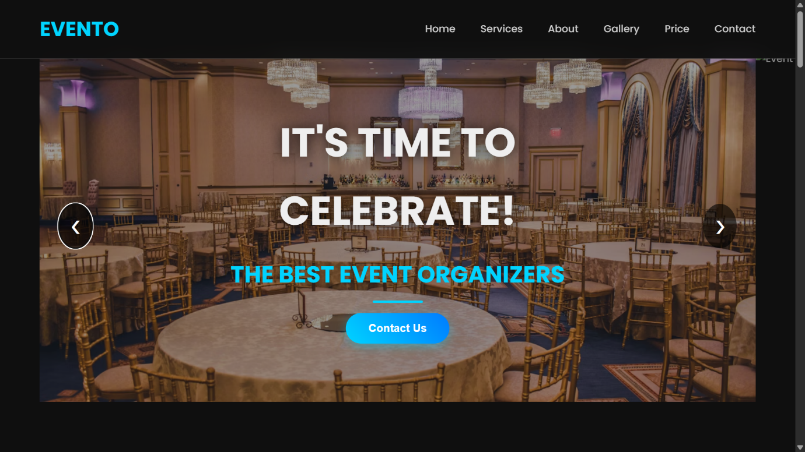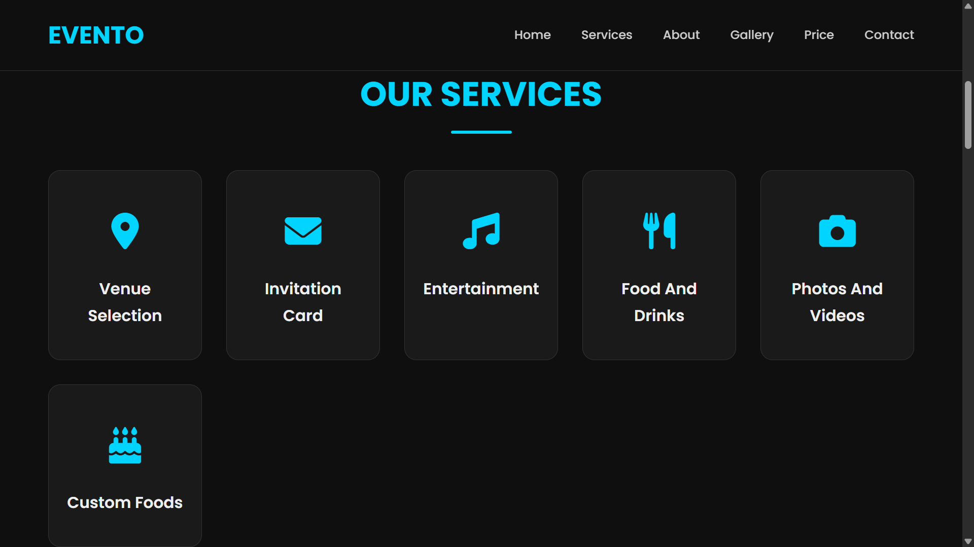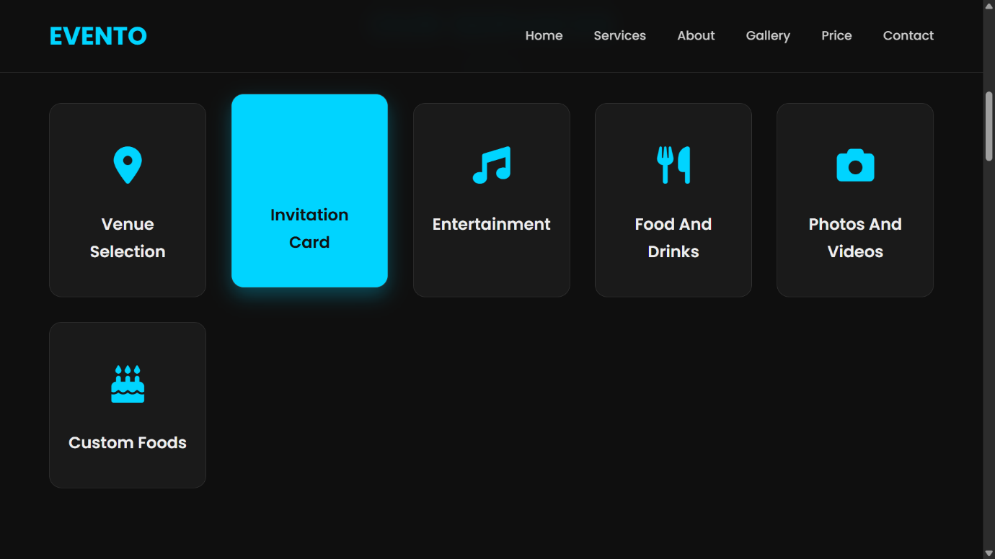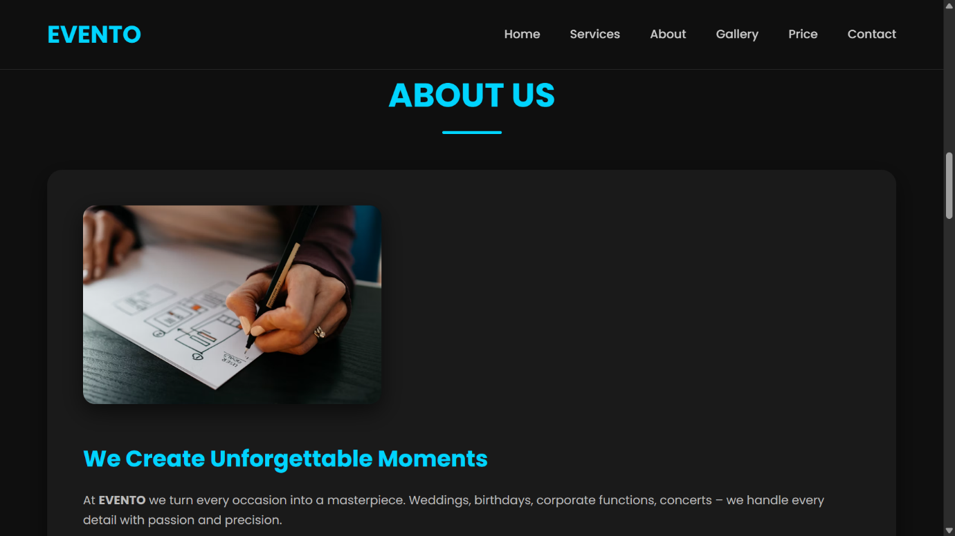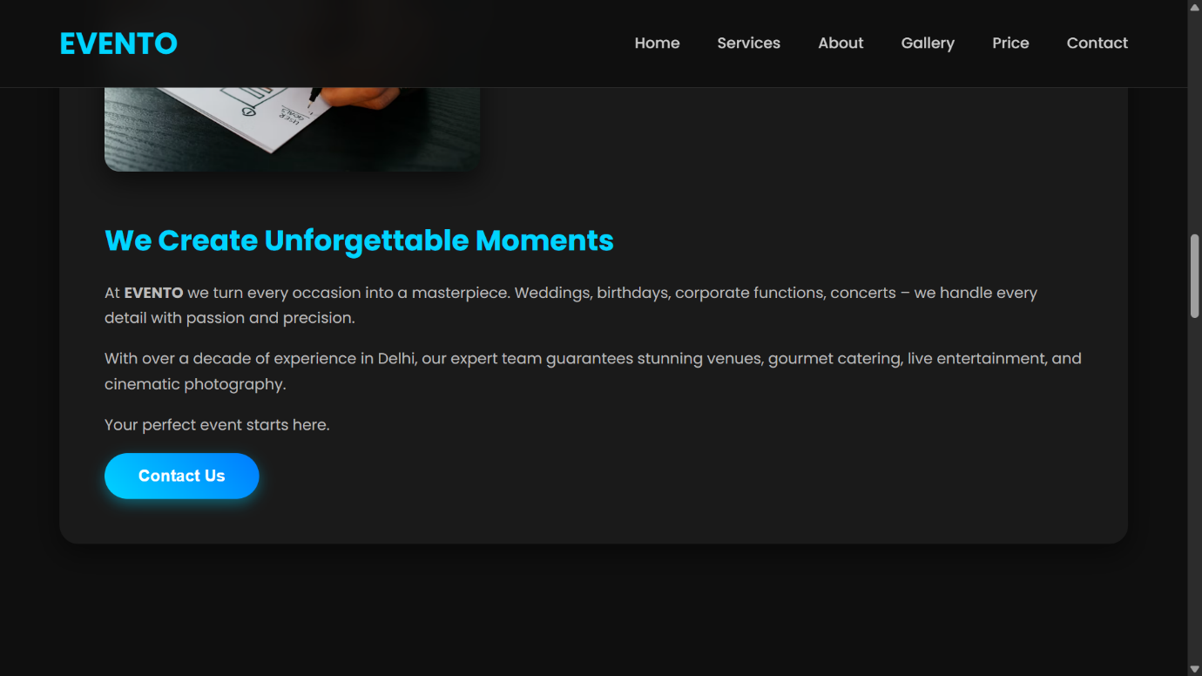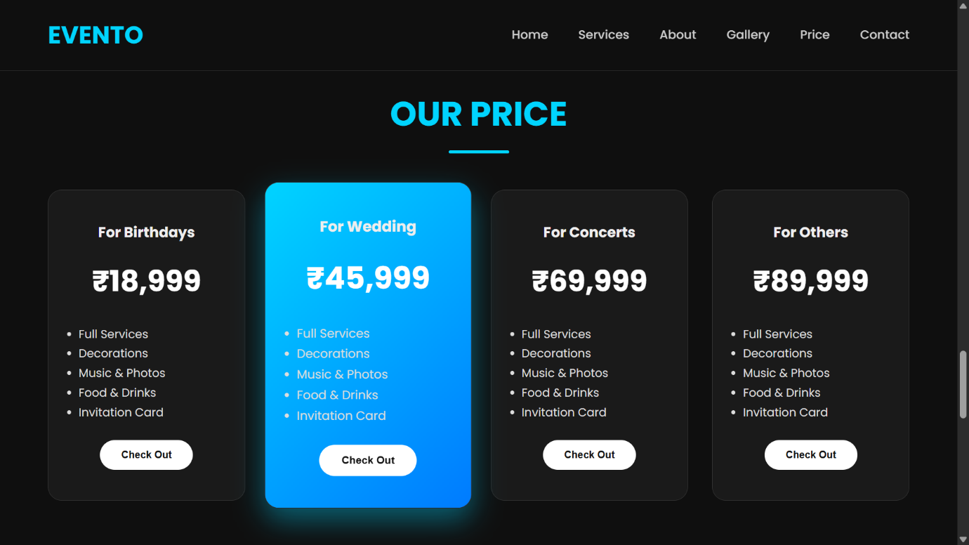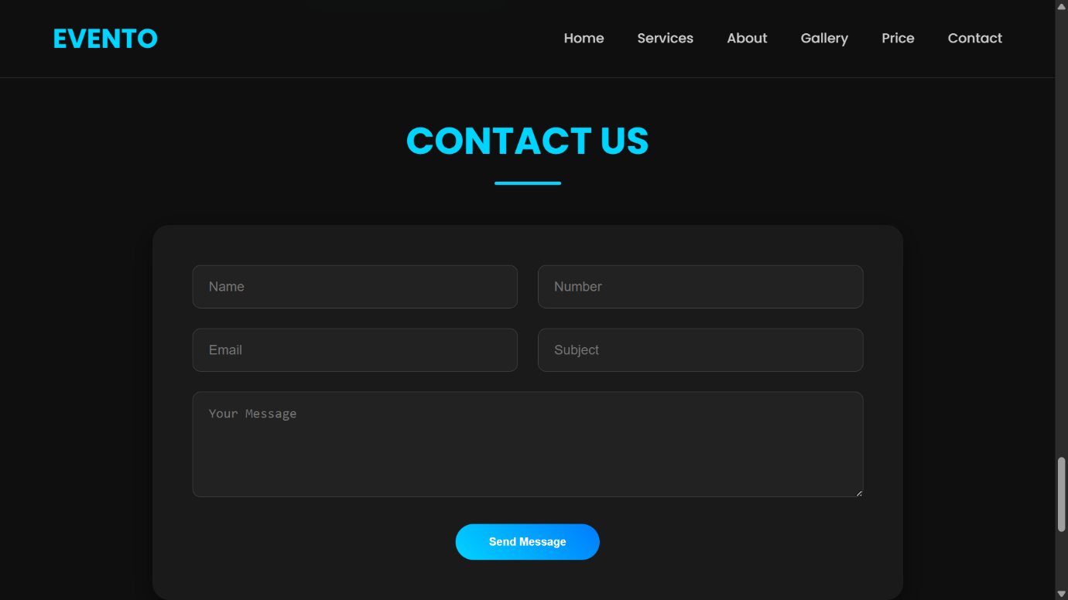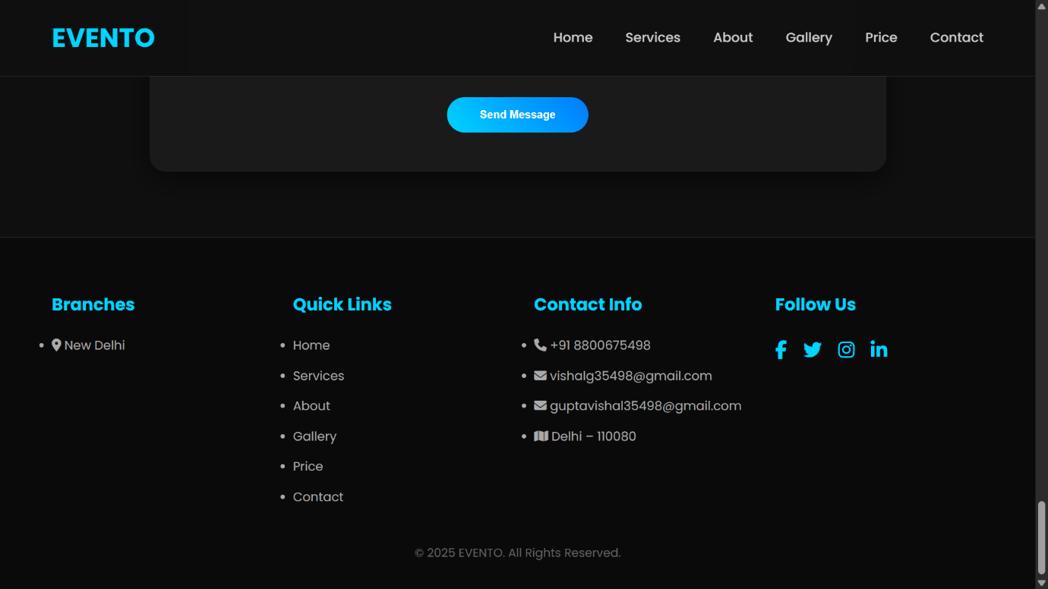

- Conclusion and Future Work

The EVENTO front-end successfully delivers a professional, modern, and responsive website, meeting the objectives of visual engagement and core service presentation.
Future Work includes:
- Backend Integration: Implementing a server-side technology (e.g., PHP, Node.js) to process and validate data from the Contact Form before storing it.
- Database Integration: Integrating a database (e.g., MySQL) to store contact leads, manage dynamic pricing, and facilitate user booking functionality.
- Advanced Content Management: Implementing dynamic loading for the Gallery and Services sections, allowing owners to update content without modifying the code.

- References

- Google Fonts:
https://fonts.googleapis.com/css2?family=Poppins:wght@400;500;600;700&display=swap
- Font Awesome Icons: https://cdnjs.cloudflare.com/ajax/libs/font-awesome/6.5.0/css/all.min.css
- HTML/CSS/JS Codebase: EVENTO Project Source Code (Provided index.html file)

